|  |  |  |
| --- | --- | --- |
| C:\Users\TNP\Desktop\NMVPM_LOGO.jpg | **Nutan Maharashtra Vidya Prasarak Mandal’s**  **NUTAN MAHARASHTRA INSTITUTE OF ENGINEERING AND TECHNOLOGY** | C:\Users\TNP\Desktop\NMVP_LOGO.jpg |

**Department of**

**Information Technology**



**LABORATORY MANUAL**

**SUBJECT: Operating System Lab**

**[SUBJECT CODE: 314446]**

**CLASS: T.E. IT**

**YEAR: 2024-25**

**PREPARED BY: APPROVED BY:**

**(Supriya Bhosale) H.O.D. [IT]**

**Vision and Mission of the Institute**

1. **Vision of the Institute-**To be a notable institution for providing quality technical education, ensuring ethical, moral, and holistic development of students.
2. **Mission of the Institute**- To nurture engineering graduates with highest technical competence, professionalism and problem solving skills to serve the needs of industry and society.

**Vision and Mission of the Department**

**Department Vision:**

* To be a notable and competent education provider in the field of Information Technology to develop professionals for serving the needs of an industry and society.

**Department Mission:**

* To provide a quality education through the state-of-the-art resources to build technologically competent individuals.
* To provide a learning ambiance to enhance Innovations, Problem-Solving Skills, Leadership qualities, Team Spirit, and Ethical Responsibilities.
* To enhance the Employability and Entrepreneurship through Industry Institute association.
* To promote graduates with Professionalism and sense of gratitude towards society

**Program Educational Objectives (PEOs):**

**PEO1 :** Possess strong fundamental concepts in mathematics, science, engineering and Technology to address technological challenges  
  
**PEO2 :** Possess knowledge and skills in the field of Computer Science and Information Technology for analysing, designing and implementing complex engineering problems of any domain with innovative approaches and Possess an attitude and aptitude for research, entrepreneurship and higher studies.  
  
**PEO3 :** Have commitment ethical practices, societal contributions through communities and life-long learning.  
  
**PEO4 :** Possess better communication, presentation, time management and team work skills leading to responsible & competent professional sand will be able to address challenges in the field of IT at global level.

**Program Outcomes**

1. **Engineering knowledge**:

Graduates can apply the knowledge of mathematics, science, engineering fundamentals and an engineering specialization to Civil Engineering related problems.

2. **Problem analysis**:

An ability to identify, formulate, review research literature, and analyse Civil engineering problems reaching substantiated conclusions using principles of mathematics and engineering sciences.

3. **Design/development of solutions**:

An ability to plan, analyse, design, and implement engineering problems and design system components or processes to meet the specified needs.

4. **Conduct investigations of complex problems**:

An ability to use research-based knowledge and research methods including design of experiments, analysis and interpretation of data, and synthesis of the information to provide valid conclusions.

5. **Modern tool usage**:

An ability to apply appropriate techniques, resources, and modern engineering and IT tools including prediction and modelling to complex engineering activities with an understanding of the limitations.

6. **The engineer and society**:

An ability to apply contextual knowledge to assess societal, legal issues and the consequent responsibilities relevant to the professional engineering practice.

7. **Environment and sustainability**:

An ability to understand the impact of the professional engineering solutions in societal and environmental contexts, and demonstrate the knowledge of, and need for sustainable development.

8. **Ethics**:

An ability to apply ethical principles and commit to professional ethics and responsibilities and norms of the engineering practice.

9. **Individual and teamwork**:

An ability to function effectively as an individual, and as a member or leader in diverse teams, and in multidisciplinary settings to accomplish a common goal.

10. **Communication**:

An ability to communicate effectively on engineering activities with the engineering community and with society at large, such as, being able to comprehend and write effective reports and design documentation and make effective presentations.

11. **Project management and finance**:

Ability to demonstrate knowledge and understanding of the engineering and management principles and apply these to one’s own work, as a member and leader in a team, to manage projects and in multidisciplinary environments.

12. **Life-long learning**:

An ability to engage in independent and life-long learning in the broadest context of technological change.

**Program Educational Objectives (PEOs)**

**PEO1 :** Possess strong fundamental concepts in mathematics, science, engineering and Technology to address technological challenges  
  
**PEO2 :** Possess knowledge and skills in the field of Computer Science and Information Technology for analysing, designing and implementing complex engineering problems of any domain with innovative approaches and Possess an attitude and aptitude for research, entrepreneurship and higher studies.  
  
**PEO3 :** Have commitment ethical practices, societal contributions through communities and life-long learning.  
  
**PEO4 :** Possess better communication, presentation, time management and team work skills leading to responsible & competent professional sand will be able to address challenges in the field of IT at global level.

**Program Specific Outcome (PSOs)**

**PSO1** - An ability to apply the theoretical concepts and practical knowledge of Information Technology in analysis, design, development and management of information processing systems and applications in the interdisciplinary domain to understand the professional, business and business processes, ethical,legal, security and social issues and responsibilities.  
  
**PSO2** - An ability to analyze a problem and identify and define the computing infrastructure and operations requirements appropriate to its solution. IT graduates should be able to work on large-scale computing systems.

**Course Outcomes (CO)**

|  |  |
| --- | --- |
| **IT306.1** | To introduce and learn Linux commands required for administration. |
| **IT306.2** | To learn shell programming concepts and applications. |
| **IT306.3** | To demonstrate the functioning of OS basic building blocks like processes, threads under the  LINUX. |
| **IT306.4** | To demonstrate the functioning of OS concepts in user space like concurrency control (process synchronization, mutual exclusion), CPU Scheduling, Memory Management and Disk Scheduling in LINUX. |
| **IT306.5** | To demonstrate the functioning of Inter Process Communication under LINUX. |
| **IT306.6** | To study the functioning of OS concepts in kernel space like embedding the system call in any LINUXkernel. |

|  |  |  |  |
| --- | --- | --- | --- |
| **List of Experiments with Mapping** | | | |
| **Sr. No.** | **Name of the Experiment** | **CO mapping** | **Level of CO mapping** |
| 1. | Study of Basic Linux Commands: echo, ls, read, cat, touch, test, loops, arithmetic comparison, conditional loops, grep, sed etc. | **IT306.1** | 1 |
| 2. | Write a program to implement an address book with options given below: a) Create address book. b) View address book. c) Insert a record. d) Delete a record. e) Modify a record. f) Exit | **IT306.2** | 2 |
| 3. | Implement the C program in which main program accepts the integers to be sorted. Main program uses the FORK system call to create a new process called a child process. Parent process sorts the integers using sorting algorithm and waits for child process using WAIT system call to sort the integers using any sorting algorithm. Also demonstrate zombie and orphan states. | **IT306.3** | 3 |
| 4. | Implement the C program in which main program accepts an array. Main program uses the FORK system call to create a new process called a child process. Parent process sorts an array and passes the sorted array to child process through the command line arguments of EXECVE system call. The child process uses EXECVE system call to load new program which display array in reverse order. | **IT306.3** | 3 |
| 5. | Implement the C program for CPU Scheduling Algorithms: Shortest Job First (Preemptive) and Round Robin with different arrival time. | **IT306.4** | 2 |
| 6. | Thread synchronization using counting semaphores. Application to demonstrate: producer- consumer problem with counting semaphores and mutex. | **IT306.4** | 2 |
| 7. | Thread synchronization and mutual exclusion using mutex. Application to demonstrate: Reader- Writer problem with reader priority. | **IT306.4** | 3 |
| 8. | Implement the C program for Deadlock Avoidance Algorithm: Bankers Algorithm. | **IT306.4** | 2 |
| 9. | Implement the C program for Page Replacement Algorithms: FCFS, LRU, and Optimal for frame size as minimum three. | **IT306.4** | 2 |
| 10. | Inter process communication in Linux using following.  A. FIFOS: | **IT306.5** | 3 |
| 11. | Implement the C program for Disk Scheduling Algorithms: SSTF, SCAN, C-Look considering the initial head position moving away from the spindle. | **IT306.6** | 2 |
| 12. | Implement a new system call in the kernel space, add this new system call in the Linux kernel by the compilation of this kernel (any kernel source, any architecture and any Linux kernel distribution) and demonstrate the use of this embedded system call using C program in user space. | **IT306.6** | 2 |

**Rubrics for Evaluation**

|  |  |  |  |
| --- | --- | --- | --- |
| **Sr.**  **No** | **Evaluation Criteria** | **Marks for each Criteria** | **Rubrics** |
| 1 | Timely submission | 5 or 10 | Punctuality reflects the work ethics. Students should reflect that work ethics by completing the lab assignments and reports in a timely manner . |
| 2 | Journal Presentation | 5 or 10 | Students are expected to prepare the journal.  The journal presentation of the course should be complete, clear, and understandable. |
| 3 | Performance | 5 or 10 | After performance, the students should have good knowledge of the experiment. |
| 4 | Understanding | 5 or 10 | The student should be able to explain methodology used for designing and developing the program/solution. Student should clearly understand the purpose of the assignment and its outcome. |
| 5 | Oral | 5 or 10 | The student should be able to answer the questions related to the lab assignments. |

**EXPERIMENT NO. 01**

**Title :** Basic Linux Commands

**AIM :** Study of Basic Linux Commands: echo, ls, read, cat, touch, test, loops, arithmetic

comparison, conditional loops, grep, sed etc.

**Theory :**

Linux Basic Commands

1. pwd command

Use the pwd command to find out the path of the current working directory (folder)

you’re in. The command will return an absolute (full) path, which is basically a path of

all the directories that starts with a forward slash (/). An example of an absolute path

is /home/username.

2. cd command

To navigate through the Linux files and directories, use the cd command. It requires

either the full path or the name of the directory, depending on the current working

directory that you’re in.

Let’s say you’re in /home/username/Documents and you want to go to Photos, a

subdirectory of Documents. To do so, simply type the following command: cd Photos.

Another scenario is if you want to switch to a completely new directory, for

example,/home/username/Movies. In this case, you have to type cd followed by the

directory’s absolute path: cd /home/username/Movies.

There are some shortcuts to help you navigate quickly:

cd .. (with two dots) to move one directory up

cd to go straight to the home folder

Information Technology Dept. Operating Systems Lab Manual

P:F:-LTL-UG / 03 / R1 Sheet 3 of 74

cd- (with a hyphen) to move to your previous directory

On a side note, Linux’s shell is case sensitive. So, you have to type the name’s

directory exactly as it is.

3. ls command

The ls command is used to view the contents of a directory. By default, this command

will display the contents of your current working directory.

If you want to see the content of other directories, type ls and then the directory’s path.

For example, enter ls /home/username/Documents to view the content of Documents.

There are variations you can use with the ls command:

ls -R will list all the files in the sub-directories as well

ls -a will show the hidden files

ls -al will list the files and directories with detailed information like the

permissions, size, owner, etc.

4. cat command

cat (short for concatenate) is one of the most frequently used commands in Linux. It is

used to list the contents of a file on the standard output (sdout). To run this command,

type cat followed by the file’s name and its extension. For instance: cat file.txt.

Here are other ways to use the cat command:

cat > filename creates a new file

cat filename1 filename2>filename3 joins two files (1 and 2) and stores the

output of them in a new file (3)

to convert a file to upper or lower case use, cat filename | tr a-z A-

Z >output.txt

5. cp command

Use the cp command to copy files from the current directory to a different directory.

For instance, the command cp scenery.jpg /home/username/Pictures would create a

copy of scenery.jpg (from your current directory) into the Pictures directory.

6. mv command

The primary use of the mv command is to move files, although it can also be used to

rename files.

The arguments in mv are similar to the cp command. You need to type mv, the file’s

name, and the destination’s directory. For example: mv file.txt

/home/username/Documents.

To rename files, the Linux command is mv oldname.ext newname.ext

7. mkdir command

Use mkdir command to make a new directory — if you type mkdir Music it will

create a directory called Music.

There are extra mkdir commands as well:

To generate a new directory inside another directory, use this Linux basic

command mkdir Music/Newfile

use the p (parents) option to create a directory in between two existing

directories. For example, mkdir -p Music/2020/Newfile will create the new

“2020” file.

8. rmdir command

If you need to delete a directory, use the rmdir command. However, rmdir only allows

you to delete empty directories.

9. rm command

The rm command is used to delete directories and the contents within them. If you

only want to delete the directory — as an alternative to rmdir — use rm -r.

Note: Be very careful with this command and double-check which directory you are in.

This will delete everything and there is no undo.

10. touch command

The touch command allows you to create a blank new file through the Linux command

line. As an example, enter touch /home/username/Documents/Web.html to create an

HTML file entitled Web under the Documents directory.

11. locate command

You can use this command to locate a file, just like the search command in Windows.

What’s more, using the -i argument along with this command will make it case-

insensitive, so you can search for a file even if you don’t remember its exact name.

To search for a file that contains two or more words, use an asterisk (\*). For

example, locate -i school\*note command will search for any file that contains the

word “school” and “note”, whether it is uppercase or lowercase.

12. find command

Similar to the locate command, using find also searches for files and directories. The

difference is, you use the find command to locate files within a given directory.

As an example, find /home/ -name notes.txt command will search for a file

called notes.txt within the home directory and its subdirectories.

Other variations when using the find are:

To find files in the current directory use, find . -name notes.txt

To look for directories use, / -type d -name notes. txt

13. grep command

Another basic Linux command that is undoubtedly helpful for everyday use is grep. It

lets you search through all the text in a given file.

To illustrate, grep blue notepad.txt will search for the word blue in the notepad file.

Lines that contain the searched word will be displayed fully.

14. sudo command

Short for “SuperUser Do”, this command enables you to perform tasks that require

administrative or root permissions. However, it is not advisable to use this command

for daily use because it might be easy for an error to occur if you did something wrong.

15. df command

Use df command to get a report on the system’s disk space usage, shown in percentage

and KBs. If you want to see the report in megabytes, type df -m.

16. du command

If you want to check how much space a file or a directory takes, the du (Disk Usage)

command is the answer. However, the disk usage summary will show disk block

numbers instead of the usual size format. If you want to see it in bytes, kilobytes, and

megabytes, add the -h argument to the command line.

17. head command

The head command is used to view the first lines of any text file. By default, it will

show the first ten lines, but you can change this number to your liking. For example, if

you only want to show the first five lines, type head -n 5 filename.ext.

18. tail command

This one has a similar function to the head command, but instead of showing the first

lines, the tail command will display the last ten lines of a text file. For example, tail -n

filename.ext.

19. diff command

Short for difference, the diff command compares the contents of two files line by line.

After analyzing the files, it will output the lines that do not match. Programmers often

use this command when they need to make program alterations instead of rewriting the

entire source code.

The simplest form of this command is diff file1.ext file2.ext

20. tar command

The tar command is the most used command to archive multiple files into a tarball —

a common Linux file format that is similar to zip format, with compression being

optional.

This command is quite complex with a long list of functions such as adding new files

into an existing archive, listing the content of an archive, extracting the content from

an archive, and many more. Check out some practical examples to know more about

other functions.

21. chmod command

chmod is another Linux command, used to change the read, write, and execute

permissions of files and directories. As this command is rather complicated, you can

read the full tutorial in order to execute it properly.

22. chown command

In Linux, all files are owned by a specific user. The chown command enables you to

change or transfer the ownership of a file to the specified username. For

instance, chown linuxuser2 file.ext will make linuxuser2 as the owner of the file.ext.

23. kill command

If you have an unresponsive program, you can terminate it manually by using

the kill command. It will send a certain signal to the misbehaving app and instructs the

app to terminate itself.

There is a total of sixty-four signals that you can use, but people usually only use two

signals:

SIGTERM (15) — requests a program to stop running and gives it some time

to save all of its progress. If you don’t specify the signal when entering the kill

command, this signal will be used.

SIGKILL (9) — forces programs to stop immediately. Unsaved progress will

be lost.

Besides knowing the signals, you also need to know the process identification number

(PID) of the program you want to kill. If you don’t know the PID, simply run the

command ps ux.

After knowing what signal you want to use and the PID of the program, enter the

following syntax:

kill [signal option] PID.

24. man command

Confused about the function of certain Linux commands? Don’t worry, you can easily

learn how to use them right from Linux’s shell by using the man command. For

instance, entering man tail will show the manual instruction of the tail command.

**EXPERIMENT NO. 02**

**Title** : Shell Programming

**AIM**:

Write a program to implement an address book with options given below:

a) Create address book.

b) View address book.

c) Insert a record.

d) Delete a record.

e) Modify a record.

f) Exit.

**OBJECTIVE:**

This assignment helps the students understand the basic commands in Unix/Linux and how

write the shell scripts.

**THEORY:**

What Is Shell Scripting?

Being a Linux user means you play around with the command-line. Like it or not, there are

just some things that are done much more easily via this interface than by pointing and

clicking. The more you use and learn the command-line, the more you see its potential.

Well, the command-line itself is a program: the shell. Most Linux distros today use Bash,

and this is what you’re really entering commands into.

Now, some of you who used Windows before using Linux may remember batch files.

These were little text files that you could fill with commands to execute and Windows

would run them in turn. It was a clever and neat way to get some things done, like run

games in your high school computer lab when you couldn’t open system folders or create

shortcuts. Batch files in Windows, while useful, are a cheap imitation of shell scripts.

Shell scripts allow us to program commands in chains and have the system execute them as

a scripted event, just like batch files. They also allow for far more useful functions, such as

command substitution. You can invoke a command, like date, and use its output as part of a

file-naming scheme. You can automate backups and each copied file can have the current

date appended to the end of its name. Scripts aren’t just invocations of commands, either.

They’re programs in their own right. Scripting allows you to use programming functions –

such as ‘for’ loops, if/then/else statements, and so forth – directly within your operating

system’s interface. And, you don’t have to learn another language because you’re using

what you already know: the command-line.

Shell scripts are executed in a separate child shell process. This is done by providing

special interpreter line at the beginning (starting with #!).

To run the script we make it executable and then invoke the script name.

$ chmod +x script.sh or $ chmod 755 script.sh

$ script.sh

User can explicitly spawn a child shell of his choice with the script name as argument. In

this case it is not mandatory to include the interpreter line.

read: Making Scripts Interactive-

The read statement is the shell’s internal tool for taking inputs from the user, i.e., making

scripts interactive. It is used with one or more variable. When we use a statement like

read name

The script pauses at that point to take i/p from the keyboard. Since this is the form of

assignment, no $ is used before name.

Using Command-Line Arguments

The shell script accepts arguments from the command line. The first argument is read by

shell into parameter $1, second into $2, and so on.

Special Parameter used by Shell:

$\* - It stores complete set of positional parameters as a single string.

$# - It is set to number of arguments specified. Used to check whether right

number of argument have been entered.

$0 - Holds the command name itself.

“$@” - Each Quoted string treated as a separate argument.

$? - Exit Status of Last Command.

exit and EXIT STATUS OF COMMAND

exit - Command to terminate a program. This command is generally run with numeric

arguments.

exit0 - When everything went fine

exit1 - When something went wrong

exit2 - Failure in opening a file.

Example:

$ grep “director” emp.lst >/home/vishal; echo$?

“All command returns an exit Status”

Logical Operators && and || - Conditional Execution

Cmd1 && Cmd2: The Cmd2 will execute only when Cmd1 is succeeds.

Cmd1 || Cmd2: The Cmd2 will execute only when Cmd1 is fails.

Example:

$ grep “director” emp.lst >/home/vishal && echo “Pattern found in file”

$ grep “manager” emp.lst >/home/vishal || echo “Pattern not found in file”

THE if CONDITIONAL

if command is successful

then

execute command

else

execute command

fi

if command is successful

then

execute command

fi

if command is successful

then

execute command

elif command is successful

then ….

else …..

fi

Form 1 Form 2 Form 3

Using test and [] to evaluate expressions

When we use if to evaluate expressions, we require the test statement because the true or

false values returned by expressions cant be directly handled by if.

test use certain operator to evaluate the condition on its right and returns either true or false

exit status, which is then used by if for making decisions.

test works in 3 ways:

Compare two numbers

Compare two strings or a single string for a null value

Check a file attribute

Numeric Comparison

The numeric comparison operators always begin with a – (hyphen), followed by two

character word, and enclosed either side by a whitespace.

Example:

$ x=5; y=7; z=7.2

$test $x –eq $y; echo $?

1

$test $z –eq $y; echo $?

0

Numeric comparison is restricted to integers only.

Operators: -eq, -ne, -gt, -ge, -lt, -le.

String Comparison

Another set of operator is used for string comparison.

String tests used by test

Test True if

S1 = S2 String S1 is equal to String S2

S1 != S2 String S1 is not equal to String S2

-n stg String stg is not a null String

-z stg String stg is a null String

stg String stg is assigned and not a null String

test also permits the checking of more than one condition in the same line using the –a

(AND) and –o(OR) operators.

Example:

if [ -n “$pname” –a -n “$flname” ] ; then

demo.sh “$pname” “$flname”

else

echo “ At least one input was null string ” ; exit 1

fi

File Tests

test can be used to test various file attributes like its type or permissions.

Example:

#!/bin/sh

if [ ! -e $1 ] ; then

echo “ File does not exists ”

elif [ ! -r $1 ] ; then

echo “ File is not readable ”

elif [ ! -w $1 ] ; then

echo “ File is not writable ”

else

echo “ File is both readable and writable ”

fi

File – Related Tests with test

Test true if

-f file file exists and is a regular file

-r file file exists and is a readable

-w file file exists and is a writable

-x file file exists and is a executable

-d file file exists and is a directory

-s file file exists and has a size greater than zero

THE case CONDITIONAL

case statement matches an expression or string for more than one alternative, in more

efficient manner than if.

Form:

case expr in

pattern 1) cmd1 ;;

pattern 2) cmd2 ;;

pattern 3) cmd3 ;;

esac

expr : Computation and String Handling

The shell relies on external expr command for computing features.

Functions of expr:

o Perform arithmetic operations on integers

o Manipulate strings

Computation

expr can perform four basic arithmetic operation as well as modulus function

String Handling

expr can perform 3 important string functions

o Determine the length of the string.

o Extract a sub-string.

o Locate the position of a character in a string

Assignments

1. Use a script to take two numbers as arguments and output their sum using

i) bc ii) expr.

Include error checking to test if two arguments were entered.

2. Write a shell script that uses find to look for a file and echo a suitable msg if the file

is not found. You must not store the find output in a file.

**EXPERIMENT NO. 03**

**Title :** Process Control System Calls

**AIM:**

Process control system calls: The demonstration of FORK, EXECVE and WAIT system

calls along with zombie and orphan states.

1. Implement the C program in which main program accepts the integers to be sorted.

Main program uses the FORK system call to create a new process called a child

process. Parent process sorts the integers using sorting algorithm and waits for child

process using WAIT system call to sort the integers using any sorting algorithm.

Also demonstrate zombie and orphan states.

2. Implement the C program in which main program accepts an integer array. Main

program uses the FORK system call to create a new process called a child process.

Parent process sorts an integer array and passes the sorted array to child process

through the command line arguments of EXECVE system call. The child process

uses EXECVE system call to load new program which display array in reverse

order.

OBJECTIVE:

This assignment covers the UNIX process control commonly called for process creation,

program execution and process termination. Also covers process model, including process

creation, process destruction, zombie and orphan processes.

THEORY:

Process in UNIX:

A process is the basic active entity in most operating-system models.

Process IDs

Each process in a Linux system is identified by its unique process ID, sometimes referred

to as pid. Process IDs are 16-bit numbers that are assigned sequentially by Linux as new

processes are created.

When referring to process IDs in a C or C++ program, always use the pid\_t typedef, which

is defined in <sys/types.h>.A program can obtain the process ID of the process it’s running

in with the getpid() system call, and it can obtain the process ID of its parent process with

the getppid() system call.

Creating Processes

Two common techniques are used for creating a new process.

using system() function.

2. using fork() system calls.

1. Using system

The system function in the standard C library provides an easy way to execute a command

from within a program, much as if the command had been typed into a shell. In fact, system

creates a subprocess running the standard Bourne shell (/bin/sh)and hands the command to

that shell for execution.

The system function returns the exit status of the shell command. If the shell itself cannot

be run, system returns 127; if another error occurs, system returns –1.

2. Using fork

A process can create a new process by calling fork. The calling process becomes the parent,

and the created process is called the child. The fork function copies the parent's memory

image so that the new process receives a copy of the address space of the parent. Both

processes continue at the instruction after the fork statement (executing in their respective

memory images).

SYNOPSIS

#include <unistd.h>

pid\_t fork(void);

The fork function returns 0 to the child and returns the child's process ID to the parent.

When fork fails, it returns –1.

The wait Function

When a process creates a child, both parent and child proceed with execution from the

point of the fork. The parent can execute wait to block until the child finishes. The wait

function causes the caller to suspend execution until a child's status becomes available or

until the caller receives a signal.

SYNOPSIS

#include <sys/wait.h>

pid\_t wait(int \*status);

If wait returns because the status of a child is reported, these functions return the process ID

of that child. If an error occurs, these functions return –1.

Example:

pid\_t childpid;

childpid = wait(NULL);

if (childpid != -1)

printf("Waited for child with pid %ld\n", childpid);

Status values

The status argument of wait is a pointer to an integer variable. If it is not NULL, this function

stores the return status of the child in this location. The child returns its status by calling

exit, \_exit or return from main.

A zero return value indicates EXIT\_SUCCESS; any other value indicates EXIT\_FAILURE.

POSIX specifies six macros for testing the child's return status. Each takes the status value

returned by a child to wait as a parameter. Following are the two such macros:

SYNOPSIS

#include <sys/wait.h>

WIFEXITED(int stat\_val)

WEXITSTATUS(int stat\_val)

New program execution within the existing process (The exec Function)

The fork function creates a copy of the calling process, but many applications require the

child process to execute code that is different from that of the parent. The exec family of

functions provides a facility for overlaying the process image of the calling process with a

new image. The traditional way to use the fork–exec combination is for the child to execute

(with an exec function) the new program while the parent continues to execute the original

code.

SYNOPSIS

#include <unistd.h>

extern char \*\*environ;

1. int execl(const char \*path, const char \*arg0, ... /\*, char \*(0) \*/);

2. int execle (const char \*path, const char \*arg0, ... /\*, char \*(0),

char \*const envp[] \*/);

3. int execlp (const char \*file, const char \*arg0, ... /\*, char \*(0) \*/);

4. int execv(const char \*path, char \*const argv[]);

5. int execve (const char \*path, char \*const argv[], char \*const envp[]);

6. int execvp (const char \*file, char \*const argv[]);

exec() system call:

The exec() system call is used after a fork() system call by one of the two processes to

replace the memory space with a new program. The exec() system call loads a binary file

into memory (destroying image of the program containing the exec() system call) and go

their separate ways. Within the exec family there are functions that vary slightly in their

capabilities.

exec family:

1. execl() and execlp():

execl(): It permits us to pass a list of command line arguments to the program to be

executed. The list of arguments is terminated by NULL.

e.g. execl("/bin/ls", "ls", "-l", NULL);

execlp(): It does same job except that it will use environment variable PATH to

determine which executable to process. Thus a fully qualified path name would not have to

be used. The function execlp() can also take the fully qualified name as it also resolves

explicitly.

e.g. execlp("ls", "ls", "-l", NULL);

2. execv() and execvp():

execv(): It does same job as execl() except that command line arguments can be

passed to it in the form of an array of pointers to string.

e.g. char \*argv[] = ("ls", "-l", NULL);

execv("/bin/ls", argv);

execvp(): It does same job expect that it will use environment variable PATH to

determine which executable to process. Thus a fully qualified path name would not have to

be used.

e.g. execvp("ls", argv);

3. execve( ):

int execve(const char \*filename, char \*const argv[ ], char \*const envp[ ]);

It executes the program pointed to by filename. filename must be either a binary

executable, or a script starting with a line of the form: argv is an array of argument strings

passed to the new program. By convention, the first of these strings should contain the

filename associated with the file being executed. envp is an array of strings, conventionally

of the form key=value, which are passed as environment to the new program. Both argv

and envp must be terminated by a NULL pointer. The argument vector and environment

can be accessed by the called program's main function, when it is defined as:

int main(int argc, char \*argv[ ] , char \*envp[ ])]

execve() does not return on success, and the text, data, bss, and stack of the calling

process are overwritten by that of the program loaded.

All exec functions return –1 if unsuccessful. In case of success these functions never

return to the calling function.

Process Termination

Normally, a process terminates in one of two ways. Either the executing program calls the

exit() function, or the program’s main function returns. Each process has an exit code: a

number that the process returns to its parent. The exit code is the argument passed to the

exit function, or the value returned from main.

Zombie Processes

If a child process terminates while its parent is calling a wait function, the child process

vanishes and its termination status is passed to its parent via the wait call. But what

happens when a child process terminates and the parent is not calling wait? Does it simply

vanish? No, because then information about its termination—such as whether it exited

normally and, if so, what its exit status is—would be lost. Instead, when a child process

terminates, is becomes a zombie process.

A zombie process is a process that has terminated but has not been cleaned up yet. It is the

responsibility of the parent process to clean up its zombie children. The wait functions do

this, too, so it’s not necessary to track whether your child process is still executing before

waiting for it. Suppose, for instance, that a program forks a child process, performs some

other computations, and then calls wait. If the child process has not terminated at that point,

the parent process will block in the wait call until the child process finishes. If the child

process finishes before the parent process calls wait, the child process becomes a zombie.

When the parent process calls wait, the zombie child’s termination status is extracted, the

child process is deleted, and the wait call returns immediately.

Orphan Process:

An Orphan Process is nearly the same thing which we see in real world. Orphan

means someone whose parents are dead. The same way this is a process, whose parents are

dead, that means parents are either terminated, killed or exited but the child process is still

alive.

In Linux/Unix like operating systems, as soon as parents of any process are dead,

re-parenting occurs, automatically. Re-parenting means processes whose parents are dead,

means Orphaned processes, are immediately adopted by special process. Thing to notice

here is that even after re-parenting, the process still remains Orphan as the parent which

created the process is dead, Reasons for Orphan Processes:

A process can be orphaned either intentionally or unintentionally. Sometime a

parent process exits/terminates or crashes leaving the child process still running, and then

they become orphans. Also, a process can be intentionally orphaned just to keep it running.

For example when you need to run a job in the background which need any manual

intervention and going to take long time, then you detach it from user session and leave it

there. Same way, when you need to run a process in the background for infinite time, you

need to do the same thing. Processes running in the background like this are known as

daemon process.

Finding a Orphan Process:

It is very easy to spot a Orphan process. Orphan process is a user process, which is

having init (process id 1) as parent. You can use this command in linux to find the Orphan

processes.

# ps -elf | head -1; ps -elf | awk '{if ($5 == 1 && $3 != "root") {print $0}}' | head

This will show you all the orphan processes running in your system. The output

from this command confirms that they are Orphan processes but does not mean that they

are all useless, so confirm from some other source also before killing them.

Killing a Orphan Process:

As orphaned processes waste server resources, so it is not advised to have lots of

orphan processes running into the system. To kill a orphan process is same as killing a

normal process.

# kill -15 <PID>

If that does not work then simply use

# kill -9 <PID>

Daemon Process:

It is a process that runs in the background, rather than under the direct control of a

user; they are usually initiated as background processes.

vfork: alternative of fork

create a new process when exec a new program.

Compare with fork:

1. Creates new process without fully copying the address space of the parent.

2. vfork guarantees that the child runs first, until the child calls exec or exit.

3. When child calls either of these two functions(exit, exec), the parent resumes.

INPUT:

1. An integer array with specified size.

2. An integer array with specified size and number to search.

OUTPUT:

1. Sorted array.

2. Status of number to be searched.

FAQS:

Is Orphan process different from an Zombie process ?

Are Orphan processes harmful for system ?

Is it bad to have Zombie processes on your system ?

How to find an Orphan Process?

How to find a Zombie Process?

What is common shared data between parent and child process?

What are the contents of Process Control Block?

PRACTISE ASSIGNMENTS / EXERCISE / MODIFICATIONS:

Example 1

Printing the Process ID

#include <stdio.h>

#include <unistd.h>

int main()

{

printf(“The process ID is %d\n”, (int) getpid());

printf(“The parent process ID is %d\n”, (int) getppid());

return 0;

}

Example 2

Using the system call

#include <stdlib.h>

int main()

{

int return\_value;

return\_value=system(“ls –l /”);

return return\_value;

}

Example 3

Using fork to duplicate a program’s process

#include <stdio.h>

#include <unistd.h>

#include <sys/types.h>

int main()

{

pid\_t child\_pid;

printf(“The main program process ID is %d\n”, (int) getpid());

child\_pid=fork();

if(child\_pid!=0) {

printf(“This is the parent process ID, with id %d\n”, (int) getpid());

printf(“The child process ID is %d\n”, (int) chi;d\_pid);

}

Else

printf(“This is the child process ID, with id %d\n”, (int) getpid());

return 0;

}

Example 4

Determining the exit status of a child.

#include <stdio.h> #include

<sys/types.h> #include

<sys/wait.h>

void show\_return\_status(void)

{

pid\_t childpid; int

status;

childpid = wait(&status); if (childpid

== -1)

perror("Failed to wait for child");

else if (WIFEXITED(status))

printf("Child %ld terminated with return status %d\n", (long)childpid,

WEXITSTATUS(status));

}

Example 5

A program that creates a child process to run ls -l.

#include <stdio.h> #include

<stdlib.h> #include <unistd.h>

#include <sys/wait.h>

int main(void)

{

pid\_t childpid;

childpid = fork();

if (childpid == -1) { perror("Failed to

fork"); return 1;

}

if (childpid == 0) {

/\* child code \*/

execl("/bin/ls", "ls", "-l", NULL); perror("Child

failed to exec ls"); return 1;

}

if (childpid != wait(NULL)) {

/\* parent code \*/

perror("Parent failed to wait due to signal or error"); return 1;

return 0;

}

Example 6

Making a zombie process

#include <stdlib.h>

#include <sys/types.h>

#include <unistd.h>

int main()

{

pid\_t child\_pid;

//create a child process

child\_pid=fork();

if(child\_pid>0) {

//This is a parent process. Sleep for a minute

sleep(60)

}

else

{

//This is a child process. Exit immediately.

exit(0);

}

return 0;

}

Example 7

Demonstration of fork system call

#include<stdio.h>

#include <stdlib.h>

#include <sys/types.h>

#include <unistd.h>

int main()

{

pid\_t pid;

char \*msg;

int n;

printf(“Program starts\n”);

pid=fork();

switch(pid)

{

case -1:

printf(“Fork error\n”);

exit(-1);

case 0:

msg=”This is the child process”;

n=5;

break;

default:

msg=”This is the parent process”;

n=3;

break;

}

while(n>0)

{

puts(msg);

sleep(1);

n--;

}

return 0;

}

Example 8

Demo of multiprocess application using fork()system call

#include<stdio.h>

#include<unistd.h>

#include<stdlib.h>

#include<string.h>

#define SIZE 1024

void do\_child\_proc(int pfd[2]);

void do\_parent\_proc(int pfd[2]);

int main()

{

int pfd[2];

int ret\_val,nread;

pid\_t pid;

ret\_val=pipe(pfd);

if(ret\_val==-1)

{

perror(“pipe error\n”);

exit(ret\_val);

}

pid=fork();

switch(pid)

{

case -1:

printf(“Fork error\n”);

exit(pid);

case 0:

do\_child\_proc(pfd);

exit(0);

default:

do\_parent\_proc(pfd);

exit(pid);

}

wait(NULL);

return 0;

}

void do\_child\_proc(int pfd[2])

{

int nread;

char \*buf=NULL;

printf(“5\n”);

close(pfd[1]);

while(nread=(read(pfd[0],buf,size))!=0)

printf(“Child Read=%s\n”,buf);

close(pfd[0]);

exit(0);

}

void do\_parent\_proc(int pfd[2])

{

char ch;

char \*buf=NULL;

close(pfd[0]);

while(ch=getchar()!=’\n’) {

printf(“7\n”);

\*buf=ch;

buff+;

}

\*buf=’\0’;

write(pfd[1],buf,strlen(buf)+1);

close(pfd[1]);

}

**EXPERIMENT NO. 04**

**Title :** SJF & Round Robin CPU Scheduling

**AIM:** Implement C program for CPU scheduling algorithms: Shortest Job First (SJF) and

Round Robin with different arrival time.

**OBJECTIVE:** Understand SJF and RR algorithms and implement it in C

**THEORY:**

Shortest Job First scheduling works on the process with the shortest burst time or duration

first.

This is the best approach to minimize waiting time.

This is used in Batch Systems.

It is of two types:

1. Non Pre-emptive

2. Pre-emptive

To successfully implement it, the burst time/duration time of the processes should

be known to the processor in advance, which is practically not feasible all the time.

This scheduling algorithm is optimal if all the jobs/processes are available at the

same time. (either Arrival time is 0 for all, or Arrival time is same for all)

Non Pre-emptive Shortest Job First :

Consider the below processes available in the ready queue for execution, with arrival time

as 0 for all and given burst times.

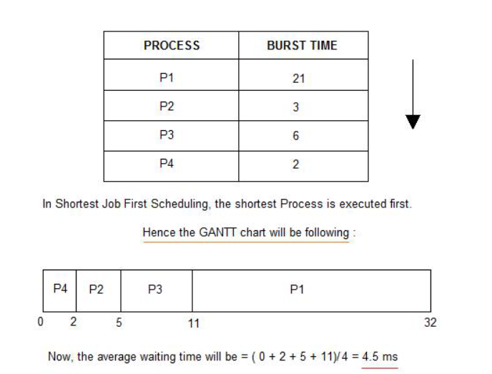

As you can see in the GANTT chart above, the process P4 will be picked up first as it has

the shortest burst time, then P2, followed by P3 and at last P1.

We scheduled the same set of processes using the First come first serve algorithm in the

previous tutorial, and got average waiting time to be 18.75 ms, whereas with SJF, the

average waiting time comes out 4.5 ms.

Problem with Non Pre-emptive SJF:

If the arrival time for processes are different, which means all the processes are not

available in the ready queue at time 0, and some jobs arrive after some time, in such

situation, sometimes process with short burst time have to wait for the current process's

execution to finish, because in Non Pre-emptive SJF, on arrival of a process with short

duration, the existing job/process's execution is not halted/stopped to execute the short job

first.

This leads to the problem of Starvation, where a shorter process has to wait for a long time

until the current longer process gets executed. This happens if shorter jobs keep coming,

but this can be solved using the concept of aging.

Pre-emptive Shortest Job First

In Preemptive Shortest Job First Scheduling, jobs are put into ready queue as they arrive,

but as a process with short burst time arrives, the existing process is preempted or

removed from execution, and the shorter job is executed first.

The average waiting time will be,((5-3)+(6-2)+(12-1))/4=8.75

The average waiting time for preemptive shortest job first scheduling is less than both,non

preemptive SJF scheduling and FCFS scheduling

As you can see in the GANTT chart above, as P1 arrives first, hence it's execution starts

immediately, but just after 1 ms, process P2 arrives with a burst time of 3 ms which is less

than the burst time of P1, hence the process P1(1 ms done, 20 ms left) is preemptied and

process P2 is executed.

As P2 is getting executed, after 1 ms, P3 arrives, but it has a burst time greater than that of

P2, hence execution of P2 continues. But after another millisecond, P4 arrives with a burst

time of 2 ms, as a result P2(2 ms done, 1 ms left) is preemptied and P4 is executed.

After the completion of P4, process P2 is picked up and finishes, then P2 will get executed

and at last P1.

The Pre-emptive SJF is also known as Shortest Remaining Time First, because at any

given point of time, the job with the shortest remaining time is executed first.

Round Robin(RR) scheduling algorithm is mainly designed for time-sharing systems. This

algorithm is similar to FCFS scheduling, but in Round Robin(RR) scheduling, preemption

is added which enables the system to switch between processes.

A fixed time is allotted to each process, called a quantum, for execution.

Once a process is executed for the given time period that process is preempted and

another process executes for the given time period.

Context switching is used to save states of preempted processes.

This algorithm is simple and easy to implement and the most important is thing is

this algorithm is starvation-free as all processes get a fair share of CPU.

It is important to note here that the length of time quantum is generally from 10 to

100 milliseconds in length.

Some important characteristics of the Round Robin(RR) Algorithm are as follows:

1. Round Robin Scheduling algorithm resides under the category of Preemptive

Algorithms.

2. This algorithm is one of the oldest, easiest, and fairest algorithm.

3. This Algorithm is a real-time algorithm because it responds to the event within a

specific time limit.

4. In this algorithm, the time slice should be the minimum that is assigned to a specific

task that needs to be processed. Though it may vary for different operating systems.

5. This is a hybrid model and is clock-driven in nature.

6. This is a widely used scheduling method in the traditional operating system.

Important terms:

1. Completion Time It is the time at which any process completes its execution.

2. Turn Around Time This mainly indicates the time Difference between completion

time and arrival time. The Formula to calculate the same is: Turn Around Time =

Completion Time – Arrival Time

3. Waiting Time(W.T): It Indicates the time Difference between turn around time and

burst time. And is calculated as Waiting Time = Turn Around Time – Burst

Time

Let us now cover an example for the same:

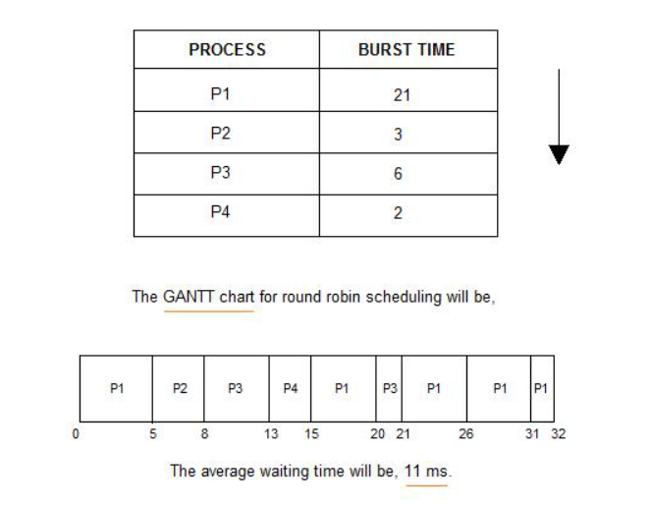

Information Technology Dept. Operating System Lab Manual

P:F:-LTL-UG / 03 / R1 Sheet 32 of 74

In the above diagram, arrival time is not mentioned so it is taken as 0 for all processes.

Note: If arrival time is not given for any problem statement then it is taken as 0 for all

processes; if it is given then the problem can be solved accordingly.

Explanation:

The value of time quantum in the above example is 5.Let us now calculate the Turn around

time and waiting time for the above example :

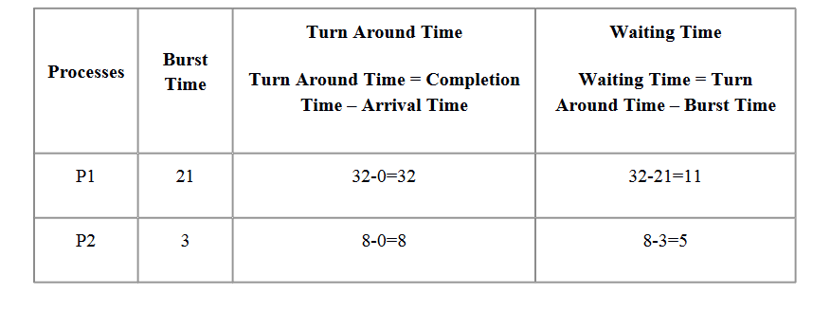 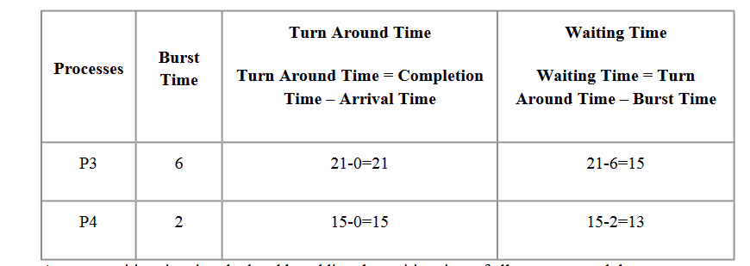

Average waiting time is calculated by adding the waiting time of all processes and then

dividing them by no.of processes.

average waiting time = waiting time of all processes/ no.of processes

average waiting time=11+5+15+13/4 = 44/4= 11ms

Advantages of Round Robin Scheduling Algorithm:

Some advantages of the Round Robin scheduling algorithm are as follows:

While performing this scheduling algorithm, a particular time quantum is allocated

to different jobs.

In terms of average response time, this algorithm gives the best performance.

With the help of this algorithm, all the jobs get a fair allocation of CPU.

In this algorithm, there are no issues of starvation or convoy effect.

This algorithm deals with all processes without any priority.

This algorithm is cyclic in nature.

In this, the newly created process is added to the end of the ready queue.

Also, in this, a round-robin scheduler generally employs time-sharing which means

providing each job a time slot or quantum.

In this scheduling algorithm, each process gets a chance to reschedule after a

particular quantum time.

Disadvantages of Round Robin Scheduling Algorithm:

This algorithm spends more time on context switches.

For small quantum, it is time-consuming scheduling.

This algorithm offers a larger waiting time and response time.

In this, there is low throughput.

If time quantum is less for scheduling, then its Gantt chart seems to be too big.

**EXPERIMENT NO. 05**

**TITLE:** Thread synchronization using counting semaphores.

**AIM:** Application to demonstrate producer-consumer problem with counting semaphores

and mutex.

**OBJECTIVE:** Implement C program to demonstrate producer-consumer problem with

counting semaphores and mutex.

**THEORY:**

Semaphores:

An integer value used for signaling among processes. Only three operations may be

performed on a semaphore, all of which are atomic: initialize, decrement, and increment.

The decrement operation may result in the blocking of a process, and the increment

operation may result in the unblocking of a process. Also known as a counting semaphore

or a general semaphore.

Semaphores are the OS tools for synchronization. Two types:

1. Binary Semaphore.

2. Counting Semaphore.

Counting semaphore

The counting semaphores are free of the limitations of the binary semaphores. A counting

semaphore comprises:

An integer variable, initialized to a value K (K>=0). During operation it can assume any

value <= K, a pointer to a process queue. The queue will hold the PCBs of all those

processes, waiting to enter their critical sections. The queue is implemented as a FCFS, so

that the waiting processes are served in a FCFS order.

A counting semaphore can be implemented as follows:

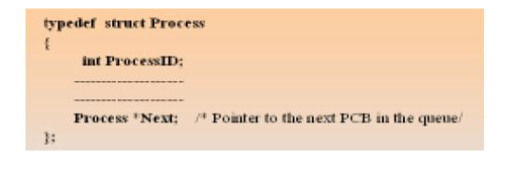 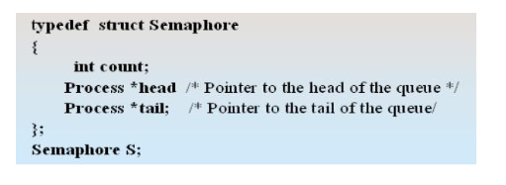 Operation of a counting semaphore:

1. Let the initial value of the semaphore count be 1.

2. When semaphore count = 1, it implies that no process is executing in its critical section

and no process is waiting in the semaphore queue.

3. When semaphore count = 0, it implies that one process is executing in its critical

section but no process is waiting in the semaphore queue.

4. When semaphore count = N, it implies that one process is executing in its critical

section and N processes are waiting in the semaphore queue.

5. When a process is waiting in semaphore queue, it is not performing any busy waiting. It

is rather in a “waiting” or “blocked” state.

6. When a waiting process is selected for entry into its critical section, it is transferred

from “Blocked” state to “ready” state.

The Producer/Consumer Problem

We now examine one of the most common problems faced in concurrent processing: the

producer/consumer problem. The general statement is this: there are one or more producers

generating some type of data (records, characters) and placing these in a buffer. There is a

single consumer that is taking items out of the buffer one at a time. The system is to be

constrained to prevent the overlap of buffer operations. That is, only one agent (producer or

consumer) may access the buffer at any one time. The problem is to make sure that the

producer won’t try to add data into the buffer if it’s full and that the consumer won’t try to

remove data from an empty buffer. We will look at a number of solutions to this problem to

illustrate both the power and the pitfalls of semaphores. To begin, let us assume that the

buffer is infinite and consists of a linear array of elements. In abstract terms, we can define

the producer and consumer functions as follows:

Figure illustrates the structure of buffer b. The producer can generate items and store them

in the buffer at its own pace. Each time, an index (in) into the buffer is incremented. The

consumer proceeds in a similar fashion but must make sure that it does not attempt to read

from an empty buffer. Hence, the

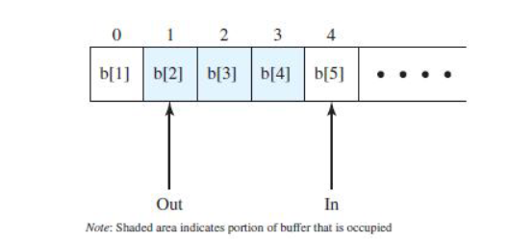

Figure: Infinite buffer for producer/consumer problem

CONCLUSION:

Thus, we have implemented producer-consumer problem using ‘C’ in Linux.

FAQ

1. Explain the concept of semaphore?

2. Explain wait and signal functions associated with semaphores.

3. What is meant by binary and counting semaphores?

**EXPERIMENT NO. 06**

**TITLE:** Thread synchronization and mutual exclusion using mutex.

**AIM:** Application to demonstrate Reader-Writer problem with reader priority.

**OBJECTIVE:** Implement C program to demonstrate Reader-Writer problem with readers

having priority using counting semaphores and mutex.

**THEORY:**

Semaphores:

An integer value used for signaling among processes. Only three operations may be

performed on a semaphore, all of which are atomic: initialize, decrement, and increment.

The decrement operation may result in the blocking of a process, and the increment

operation may result in the unblocking of a process. Also known as a countingsemaphore

or a general semaphore.

Semaphores are the OS tools for synchronization. Two types:

1. Binary Semaphore.

2. Counting Semaphore.

Counting semaphore

The counting semaphores are free of the limitations of the binary semaphores. A counting

semaphore comprises:

An integer variable, initialized to a value K (K>=0). During operation it can assume any

value <= K, a pointer to a process queue. The queue will hold the PCBs of all those

processes, waiting to enter their critical sections. The queue is implemented as a FCFS, so

that the waiting processes are served in a FCFS order.

A counting semaphore can be implemented as follows:

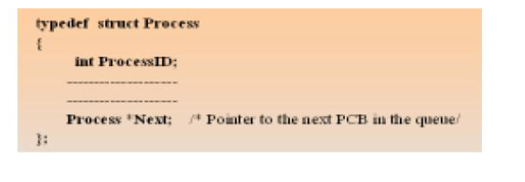 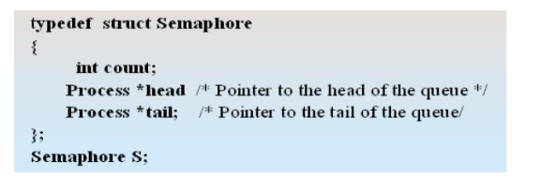

Operation of a counting semaphore:

1. Let the initial value of the semaphore count be 1.

2. When semaphore count = 1, it implies that no process is executing in its

critical section and no process is waiting in the semaphore queue.

3. When semaphore count = 0, it implies that one process is executing in its

critical section but no process is waiting in the semaphore queue.

4. When semaphore count = N, it implies that one process is executing in its

critical section and N processes are waiting in the semaphore queue.

5. When a process is waiting in semaphore queue, it is not performing any busy

waiting. It is rather in a “waiting” or “blocked” state.

6. When a waiting process is selected for entry into its critical section, it is trans

ferred from “Blocked” state to “ready” state.

Reader-Writer problem with readers priority

The readers/writers problem is defined as follows: There is a data area shared among a

number of processes. The data area could be a file, a block of main memory, or even a bank

of processor registers. There are a number of processes that only read the data area (readers)

and a number that only write to the data area (writers). The conditions that must be satisfied

are as follows:

1. Any number of readers may simultaneously read the file.

2. Only one writer at a time may write to the file.

3. If a writer is writing to the file, no reader may read it.

Thus, readers are processes that are not required to exclude one another and writers are

processes that are required to exclude all other processes, readers and writers alike. Before

proceeding, let us distinguish this problem from two others: the general mutual exclusion

problem and the producer/consumer problem. In the readers/writers problem readers do not

also write to the data area, nor do writers read the data area while writing.

A more general case, which includes this case, is to allow any of the processes to read or

write the data area. In that case, we can declare any portion of a process that accesses the

data area to be a critical section and impose the general mutual exclusion solution. The

reason for being concerned with the more restricted case is that more efficient solutions are

possible for this case and that the less efficient solutions to the general problem are

unacceptably slow.

For example, suppose that the shared area is a library catalog. Ordinary users of the library

read the catalog to locate a book. One or more librarians are able to update the catalog.

In the general solution, every access to the catalog would be treated as a critical section,

and users would be forced to read the catalog one at a time. This would clearly impose

intolerable delays. At the same time, it is important to prevent writers from interfering with

each other and it is also required to prevent reading while writing is in progress to prevent

the access of inconsistent information.

This is not a special case of producer-consumer. The producer is not just a writer. It must

read queue pointers to determine where to write the next item, and it must determine if the

buffer is full. Similarly, the consumer is not just a reader, because it must adjust the queue

pointers to show that it has removed a unit from the buffer.

Solution using semaphore:

int readcount;

semaphore x = 1,wsem = 1;

void reader()

{

while (true)

{

semWait (x);

readcount++;

if(readcount == 1)

semWait (wsem);

semSignal (x);

READUNIT();

semWait (x);

readcount;

if(readcount == 0)

semSignal (wsem);

semSignal (x);

}

}

void writer()

{

while (true)

{

semWait (wsem);

WRITEUNIT();

semSignal (wsem);

}

}

void main()

{

readcount = 0;

parbegin (reader,writer);

}

Threads

Multiple strands of execution in a single program are called threads. A more precise

definition is that a thread is a sequence of control within a process. Like many other

operating systems, Linux is quite capable of running multiple processes simultaneously.

Indeed, all processes have at least one thread of execution.

POSIX Thread in Unix

Including the file pthread.h provides us with other definitions and prototypes that we will

need in our code, much like stdio.h for standard input and output routines.

#include <pthread.h>

int pthread\_create(pthread\_t \*thread, pthread\_attr\_t\*attr,

void\*(\*start\_routine)(void \*), void \*arg);

This function is used to create the thread. The first argument is a pointer to pthread\_t.

When a thread is created, an identifier is written to the memory location to which this

variable points. This identifier enables us to refer to the thread. The next argument sets the

thread attributes. We do not usually need any special attributes, and we can simply pass

NULL as this argument. The final two arguments tell the thread the function that it is to

start executing and the arguments that are to be passed to this function.

void \*(\*start\_routine)(void \*)

We must pass the address of a function taking a pointer to void as a parameter and the

function will return a pointer to void. Thus, we can pass any type of single argument and

return a pointer to any type. Using fork causes execution to continue in the same location

with a different return code, whereas using a new thread explicitly provides a pointer to a

function where the new thread should start executing. The return value is 0 for success or

an error number if anything goes wrong.

When a thread terminates, it calls the pthread\_exit function, much as a process calls exit

when it terminates. This function terminates the calling thread, returning a pointer to an

object. Never use it to return a pointer to a local variable, because the variable will cease to

exist when the thread does so, causing a serious bug.

pthread\_exit is declared as follows:

#include <pthread.h>

void pthread\_exit(void \*retval);

pthread\_join is the thread equivalent of wait that processes use to collect child processes.

This function is declared as follows:

#include <pthread.h>

int pthread\_join(pthread\_t th, void \*\*thread\_return);

The first parameter is the thread for which to wait, the identifier that pthread\_create filled

in for us. The second argument is a pointer to a pointer that itself points to the return value

from the thread. This function returns zero for success and an error code on failure.

Linux Semaphore Facilities (Binary Semaphore)

A semaphore is created with the sem\_init function, which is declared as follows:

#include <semaphore.h>

int sem\_init(sem\_t \*sem, int pshared, unsigned int value);

This function initializes a semaphore object pointed to by sem, sets its sharing option

and gives it an initial integer value. The pshared parameter controls the type of semaphore.

If the value of pshared is 0, the semaphore is local to the current process. Otherwise, the

semaphore may be shared between processes. Here we are interested only in semaphores

that are not shared between processes. At the time of writing, Linux doesn’t support this

sharing,and passing a nonzero value for pshared will cause the call to fail.

The next pair of functions controls the value of the semaphore and is declared as follows:

#include <semaphore.h>

int sem\_wait(sem\_t \* sem);

int sem\_post(sem\_t \* sem);

These both take a pointer to the semaphore object initialized by a call to sem\_init.The

sem\_post function atomically increases the value of the semaphore by 1. Atomically here

means that if two threads simultaneously try to increase the value of a single semaphore by

1,they do not interfere with each other, as might happen if two programs read, increment,

and write a value to a file at the same time.

If both programs try to increase the value by 1, the semaphore will always be correctly

increased in value by 2.

The sem\_wait function atomically decreases the value of the semaphore by one, but always

waits until the semaphore has a nonzero count first. Thus, if you call sem\_wait on a

semaphore with a value of 2, the thread will continue executing but the semaphore will be

decreased to 1.

If sem\_wait is called on a semaphore with a value of 0, the function will wait until some

other thread has incremented the value so that it is no longer 0. If two threads are both

waiting in sem\_wait for the same semaphore to become nonzero and it is incremented once

by a third process, only one of the two waiting processes will get to decrement the

semaphore and continue; the other will remain waiting. This atomic “test and set” ability in

a single function is what makes semaphores so valuable.

The last semaphore function is sem\_destroy. This function tidies up the semaphore when

we have finished with it. It is declared as follows:

#include <semaphore.h>

int sem\_destroy(sem\_t \* sem);

Again, this function takes a pointer to a semaphore and tidies up any resources that it may

have. If we attempt to destroy a semaphore for which some thread is waiting, we will get an

error. Like most Linux functions, these functions all return 0 on success.

References :

1. “Beginning Linux Programming” by Neil Mathew and Richard Stones, Wrox

Publications.

2. “Operating System Internals and Design Implementation” by William Stallings, Pearson

Education.

CONCLUSION:

Thus, we have implemented Reader-Writer problem with readers priority using ‘C’

in Linux.

FAQ

1. Explain the concept of semaphore?

2. Explain wait and signal functions associated with semaphores.

3. What is meant by binary and counting semaphores?

**EXPERIMENT NO. 07**

**Title :** Bankers Algorithm

**AIM:** Implement C program for Deadlock Avoidance: Banker’s Algorithm

**OBJECTIVE:** Understand deadlock avoidance and implement it in C

**THEORY :**

Banker's algorithm is a deadlock avoidance algorithm. It is named so because this

algorithm is used in banking systems to determine whether a loan can be granted or not.

Consider there are n account holders in a bank and the sum of the money in all of their

accounts is S. Every time a loan has to be granted by the bank, it subtracts the loan amount

from the total money the bank has. Then it checks if that difference is greater than S. It is

done because, only then, the bank would have enough money even if all the n account

holders draw all their money at once.

Characteristics of Banker's Algorithm :

The characteristics of Banker's algorithm are as follows:

If any process requests for a resource, then it has to wait.

This algorithm consists of advanced features for maximum resource allocation.

There are limited resources in the system we have.

In this algorithm, if any process gets all the needed resources, then it is that it

should return the resources in a restricted period.

Various resources are maintained in this algorithm that can fulfill the needs of at

least one client.

Let us assume that there are n processes and m resource types.

Following data structures are required to implement banker’s algorithm for deadlock

avoidance.

Some data structures that are used to implement the banker's algorithm are:

1. Available

It is an array of length m. It represents the number of available resources of each type. If

Available[j] = k, then there are k instances available, of resource type Rj.

2. Max

It is an n x m matrix which represents the maximum number of instances of each resource

that a process can request. If Max[i][j] = k, then the process Pi can request atmost k

instances of resource type Rj.

3. Allocation

It is an n x m matrix which represents the number of resources of each type currently

allocated to each process. If Allocation[i][j] = k, then process Pi is currently allocated k

instances of resource type Rj.

4. Need

It is a two-dimensional array. It is an n x m matrix which indicates the remaining resource

needs of each process. If Need[i][j] = k, then process Pi may need k more instances of

resource type Rj to complete its task.

Need[i][j] = Max[i][j] - Allocation [i][j]

Banker’s algorithm comprises of two algorithms:

A) Safety algorithm

B) Resource request algorithm

A) Safety Algorithm

A safety algorithm is an algorithm used to find whether or not a system is in its safe

state. The algorithm is as follows:

1. Let Work and Finish be vectors of length m and n, respectively. Initially,

Work = Available

Finish[i] =false for i = 0, 1, ... , n - 1.

This means, initially, no process has finished and the number of available resources is

represented by the Available array.

2. Find an index i such that both

Finish[i] ==false

Needi <= Work

If there is no such i present, then proceed to step 4.

It means, we need to find an unfinished process whose needs can be satisfied by the

available resources. If no such process exists, just go to step 4.

3. Perform the following:

Work = Work + Allocationi

Finish[i] = true

Go to step 2.

When an unfinished process is found, then the resources are allocated and the process is

marked finished. And then, the loop is repeated to check the same for all other processes.

4. If Finish[i] == true for all i, then the system is in a safe state.

That means if all processes are finished, then the system is in safe state.

This algorithm may require an order of mxn² operations in order to determine whether a

state is safe or not.

B. Resource Request Algorithm

Now the next algorithm is a resource-request algorithm and it is mainly used to determine

whether requests can be safely granted or not.

Let Requesti be the request vector for the process Pi. If Requesti[j]==k, then process Pi

wants k instance of Resource type Rj.When a request for resources is made by the process

Pi, the following are the actions that will be taken:

1. If Requesti <= Needi, then go to step 2;else raise an error condition, since the process

has exceeded its maximum claim.

2.If Requesti <= Availablei then go to step 3; else Pi must have to wait as resources are

not available.

3.Now we will assume that resources are assigned to process Pi and thus perform the

following steps:

Available= Available-Requesti ;

Allocationi=Allocationi +Requesti;

Needi =Needi - Requesti;

If the resulting resource allocation state comes out to be safe, then the transaction is

completed and, process Pi is allocated its resources. But in this case, if the new state is

unsafe, then Pi waits for Requesti, and the old resource-allocation state is restored.

Disadvantages of Banker's Algorithm

Some disadvantages of this algorithm are as follows:

1. During the time of Processing, this algorithm does not permit a process to change its

maximum need.

2. Another disadvantage of this algorithm is that all the processes must know in

advance about the maximum resource needs.

3. This algorithm permits the requests to be provided in constrained time, but for one

year which is a fixed period.

Working Example

Example:

Let us consider the following snapshot for understanding the banker's algorithm:

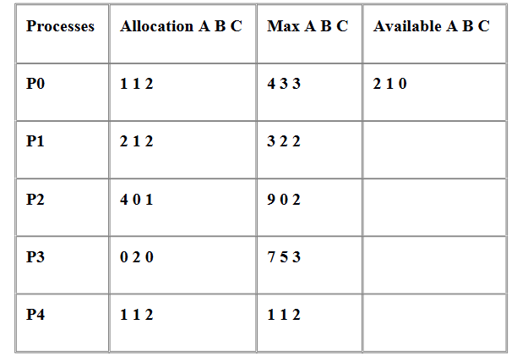

Solution:

1. The Content of the need matrix can be calculated by using the formula given below:

Need = Max – Allocation

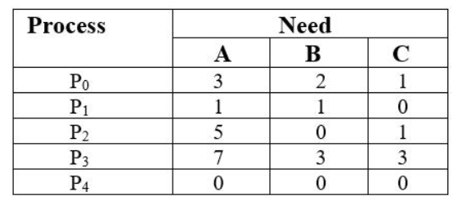

Let us now check for the safe state.

Safe sequence:

1. For process P0, Need = (3, 2, 1) and

Available = (2, 1, 0)

Need <=Available = False

So, the system will move to the next process.

2. For Process P1, Need = (1, 1, 0)

Available = (2, 1, 0)

Need <= Available = True

Request of P1 is granted.

Available = Available +Allocation

= (2, 1, 0) + (2, 1, 2)

= (4, 2, 2) (New Available)

3. For Process P2, Need = (5, 0, 1)

Available = (4, 2, 2)

Need <=Available = False

So, the system will move to the next process.

4. For Process P3, Need = (7, 3, 3)

Available = (4, 2, 2)

Need <=Available = False

So, the system will move to the next process.

5. For Process P4, Need = (0, 0, 0)

Available = (4, 2, 2)

Need <= Available = True

Request of P4 is granted.

Available = Available + Allocation

= (4, 2, 2) + (1, 1, 2)

= (5, 3, 4) now, (New Available)

6. Now again check for Process P2, Need = (5, 0, 1)

Available = (5, 3, 4)

Need <= Available = True

Request of P2 is granted.

Available = Available + Allocation

= (5, 3, 4) + (4, 0, 1)

= (9, 3, 5) now, (New Available)

7. Now again check for Process P3, Need = (7, 3, 3)

Available = (9, 3, 5)

Need <=Available = True

The request for P3 is granted.

Available = Available +Allocation

= (9, 3, 5) + (0, 2, 0) = (9, 5, 5)

8. Now again check for Process P0, = Need (3, 2, 1)

= Available (9, 5, 5)

Need <= Available = True

So, the request will be granted to P0.

Safe sequence: < P1, P4, P2, P3, P0>

The system allocates all the needed resources to each process. So, we can say that the

system is in a safe state.

3. The total amount of resources

The total amount of resources will be calculated by the following formula:

The total amount of resources= sum of columns of allocation + Available

= [8 5 7] + [2 1 0] = [10 6 7]

**EXPERIMENT NO. 07**

**Title :** Page Replacement Algorithms

**AIM:** Implement the C program for Page Replacement Algorithms: FCFS, LRU, and

Optimal for frame size as minimum three.

**OBJECTIVE:**

This assignment helps the students understand the Page Replacement Algorithms in

Unix/Linux and how to implement it in C

**THEORY:**

What are PAGE REPLACMENT Algorithms?

As studied in Demand Paging, only certain pages of a process are loaded initially

into the memory. This allows us to get more processes into memory at the same time. But

what happens when a process requests for more pages and no free memory is available to

bring them in. Following steps can be taken to deal with this problem:

1. Put the process in the wait queue, until any other process finishes its execution

thereby freeing frames.

2. Remove some other process completely from the memory to free frames.

3. Find some pages that are not being used right now, move them to the disk to get

free frames. This technique is called Page replacement and is most commonly used.

4.

In this case, if a process requests a new page and supposes there are no free frames, then

the Operating system needs to decide which page to replace. The operating system must

use any page replacement algorithm in order to select the victim frame. The Operating

system must then write the victim frame to the disk then read the desired page into the

frame and then update the page tables. And all these require double the disk access time.

1. Page replacement prevents the over-allocation of the memory by modifying the

page-fault service routine.

2. To reduce the overhead of page replacement a modify bit (dirty bit) is used in order

to indicate whether each page is modified.

3. This technique provides complete separation between logical memory and physical

memory.

Page Replacement in OS

In Virtual Memory Management, Page Replacement Algorithms play an important role.

The main objective of all the Page replacement policies is to decrease the maximum

number of page faults.

Page Fault – It is basically a memory error, and it occurs when the current programs

attempt to access the memory page for mapping into virtual address space, but it is unable

to load into the physical memory then this is referred to as Page fault.

Basic Page Replacement Algorithm in OS

Page Replacement technique uses the following approach. If there is no free frame, then we

will find the one that is not currently being used and then free it. A-frame can be freed by

writing its content to swap space and then change the page table in order to indicate that the

page is no longer in the memory.

1. First of all, find the location of the desired page on the disk.

2. Find a free Frame: a) If there is a free frame, then use it. b) If there is no free frame

then make use of the page-replacement algorithm in order to select the victim

frame. c) Then after that write the victim frame to the disk and then make the

changes in the page table and frame table accordingly.

3. After that read the desired page into the newly freed frame and then change the

page and frame tables.

1. Restart the process.

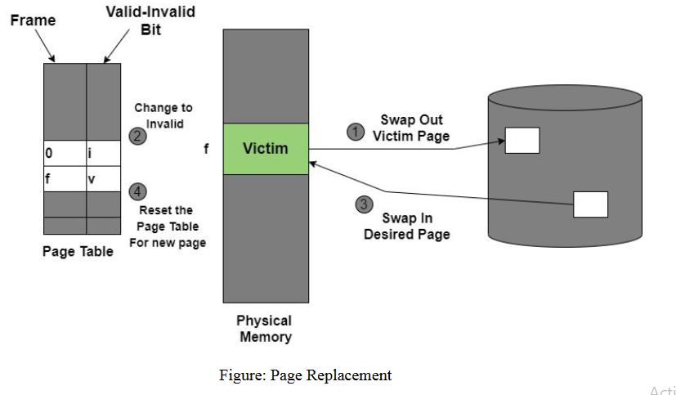

Page Replacement Algorithms in OS

This algorithm helps to decide which pages must be swapped out from the main memory in

order to create a room for the incoming page. This Algorithm wants the lowest page-fault

rate.

Various Page Replacement algorithms used in the Operating system are as follows;

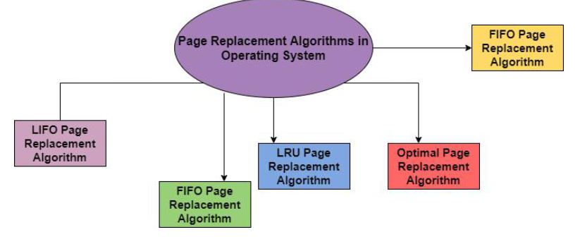

Let us discuss all algorithms one by one in the upcoming sections:

1. FIFO Page Replacement Algorithm

It is a very simple way of Page replacement and is referred to as First in First Out. This

algorithm mainly replaces the oldest page that has been present in the main memory for the

longest time.

This algorithm is implemented by keeping the track of all the pages in the queue.

As new pages are requested and are swapped in, they are added to the tail of a queue and

the page which is at the head becomes the victim.

This is not an effective way of page replacement but it can be used for small systems.

Advantages

This algorithm is simple and easy to use.

FIFO does not cause more overhead.

Disadvantages

This algorithm does not make the use of the frequency of last used time rather it just

replaces the Oldest Page.

There is an increase in page faults as page frames increases.

The performance of this algorithm is the worst.

Example:

A system uses 3 page frames for storing process pages in main memory. It uses the First in

First out (FIFO) page replacement policy. Assume that all the page frames are initially

empty. What is the total number of page faults that will occur while processing the page

reference string given below-

4 , 7, 6, 1, 7, 6, 1, 2, 7, 2

Also calculate the hit ratio and miss ratio.

Solution-

Total number of references = 10

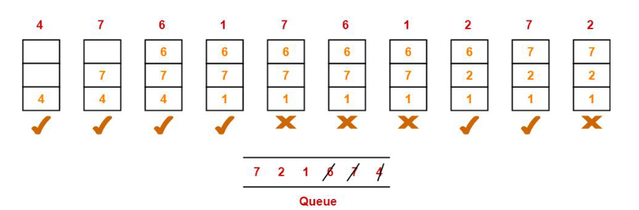

From here,

Total number of page faults occurred = 6

Calculating Hit ratio-

Total number of page hits

= Total number of references – Total number of page misses or page faults

= 10 – 6

= 4

Thus, Hit ratio

= Total number of page hits / Total number of references

= 4 / 10

= 0.4 or 40%

Calculating Miss ratio-

Total number of page misses or page faults = 6

Thus, Miss ratio

= Total number of page misses / Total number of references

= 6 / 10

= 0.6 or 60%

Alternatively,

Miss ratio

= 1 – Hit ratio

= 1 – 0.4

= 0.6 or 60%

2. LRU Page Replacement Algorithm in OS

This algorithm stands for "Least recent used" and this algorithm helps the Operating system

to search those pages that are used over a short duration of time frame.

The page that has not been used for the longest time in the main memory will be

selected for replacement.

This algorithm is easy to implement.

This algorithm makes use of the counter along with the even-page.

Advantages of LRU

It is an efficient technique.

With this algorithm, it becomes easy to identify the faulty pages that are not needed

for a long time.

It helps in Full analysis.

Disadvantages of LRU

It is expensive and has more complexity.

There is a need for an additional data structure.

Example:

A system uses 3 page frames for storing process pages in main memory. It uses the Least

Recently Used (LRU) page replacement policy. Assume that all the page frames are

initially empty. What is the total number of page faults that will occur while processing the

page reference string given below-

4 , 7, 6, 1, 7, 6, 1, 2, 7, 2

Also calculate the hit ratio and miss ratio.

Solution-

Total number of references = 10

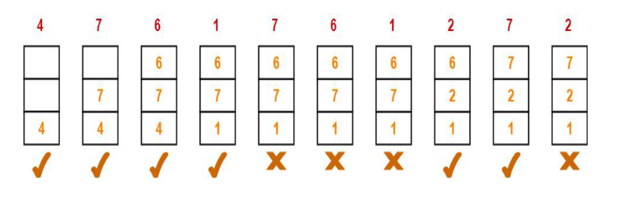

From here,

Total number of page faults occurred = 6

In the similar manner as above-

Hit ratio = 0.4 or 40%

Miss ratio = 0.6 or 60%

3. Optimal Page Replacement Algorithm

This algorithm mainly replaces the page that will not be used for the longest time in the

future. The practical implementation of this algorithm is not possible.

Practical implementation is not possible because we cannot predict in advance those

pages that will not be used for the longest time in the future.

This algorithm leads to less number of page faults and thus is the best-known

algorithm

Also, this algorithm can be used to measure the performance of other algorithms.

Advantages of OPR

This algorithm is easy to use.

This algorithm provides excellent efficiency and is less complex.

For the best result, the implementation of data structures is very easy

Disadvantages of OPR

In this algorithm future awareness of the program is needed.

Practical Implementation is not possible because the operating system is unable to

track the future request

Example:

A system uses 3 page frames for storing process pages in main memory. It uses the Optimal

page replacement policy. Assume that all the page frames are initially empty. What is the

total number of page faults that will occur while processing the page reference string given

below-

4 , 7, 6, 1, 7, 6, 1, 2, 7, 2

Also calculate the hit ratio and miss ratio.

Solution-

Total number of references = 10

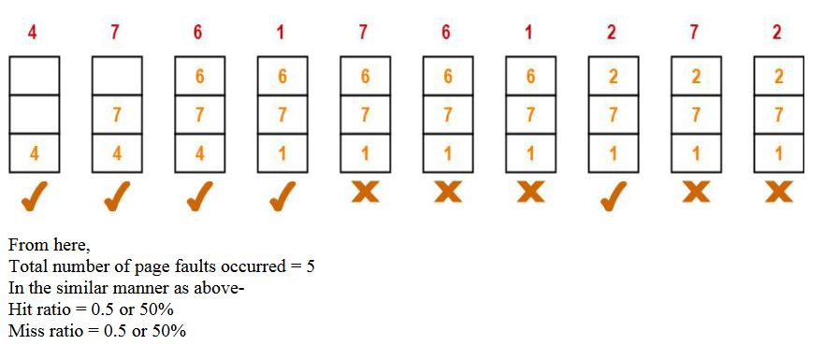

**EXPERIMENT NO. 08**

**Title** : Inter process communication

**AIM**: Inter process communication in Linux using FIFOs.

**OBJECTIVES:**

Implementation of Full duplex communication between two independent processes. First

process accepts sentences and writes on one pipe to be read by second process and second

process counts number of characters, number of words and number of lines in accepted

sentences, writes this output in a text file and writes the contents of the file on second pipe

to be read by first process and displays on standard output.

**THEORY:**

FIFOs

A first-in, first-out (FIFO) file is a pipe that has a name in the filesystem. Any

process can open or close the FIFO; the processes on either end of the pipe need not be

related to each other. FIFOs are also called named pipes

You can make a FIFO using the mkfifo command. Specify the path to the FIFO on the

command line. For example, create a FIFO in /tmp/fifo by invoking this:

% mkfifo /tmp/fifo

% ls -l /tmp/fifo

prw-rw-rw-

1 samuel users 0 Jan 16 14:04 /tmp/fifo

The first character of the output from ls is p, indicating that this file is actually a FIFO

(named pipe). In one window, read from the FIFO by invoking the following:

% cat < /tmp/fifo

In a second window, write to the FIFO by invoking this:

% cat > /tmp/fifo

Then type in some lines of text. Each time you press Enter, the line of text is sent through

the FIFO and appears in the first window. Close the FIFO by pressing Ctrl+D in the second

window. Remove the FIFO with this line:

% rm /tmp/fifo

Creating a FIFO

Create a FIFO programmatically using the mkfifo function.The first argument is the path at

which to create the FIFO; the second parameter specifies the pipe’s owner, group, and

world permissions, and a pipe must have a reader and a writer, the permissions must

include both read and write permissions. If the pipe cannot be created (for instance, if a file

with that name already exists), mkfifo returns –1. Include<sys/types.h> and <sys/stat.h> if

you call mkfifo.

Accessing a FIFO

Access a FIFO just like an ordinary file. To communicate through a FIFO, one program

must open it for writing, and another program must open it for reading. Either low-level I/O

functions like open, write, read, close or C library I/O functions (fopen, fprintf, fscanf,

fclose, and soon) may be used.

For example, to write a buffer of data to a FIFO using low-level I/O routines, you could use this

code:

intfd = open (fifo\_path, O\_WRONLY);

write (fd, data, data\_length);

close (fd);

To read a string from the FIFO using C library I/O functions, you could use this code:

FILE\* fifo = fopen (fifo\_path, “r”);

fscanf (fifo, “%s”, buffer);

fclose (fifo);

A FIFO can have multiple readers or multiple writers. Bytes from each writer are written

atomically up to a maximum size of PIPE\_BUF (4KB on Linux). Chunks from

simultaneous writers can be interleaved. Similar rules apply to simultaneous reads.

CONCLUSION:

Thus, we studied inter process communication using FIFOs.

**EXPERIMENT NO. 9**

**TITLE:** Inter-process Communication using Shared Memory using System V.

**AIM:** Application to demonstrate: Client and Server Programs in which server process

creates a shared memory segment and write the message to the shared memory segment.

Client process reads the message from the shared memory segment and displays it to the

screen.

**THEORY:**

Shared Memory

Shared memory allows two unrelated processes to access the same logical memory. Shared

memory is a very efficient way of transferring data between two running processes. Shared

memory is a special range of addresses that is created by IPC for one process and appears

in the address space of that process.

Other processes can then “attach” the same shared memory segment into their own address

space. All processes can access the memory locations just as if the memory had been

allocated by malloc. If one process writes to the shared memory, the changes immediately

become visible to any other process that has access to the same shared memory.

Shared memory provides an efficient way of sharing and passing data between multiple

processes. By itself, shared memory doesn’t provide any synchronization facilities.

Because it provides no synchronization facilities, we usually need to use some other

mechanism to synchronize access to the shared memory.

Typically, we use shared memory to provide efficient access to large areas of memory and

pass small messages to synchronize access to that memory. There are no automatic

facilities to prevent a second process from starting to read the shared memory before the

first process has finished writing to it. It’s the responsibility of the programmer to

synchronize access. Figure below shows an illustration of how shared memory works.

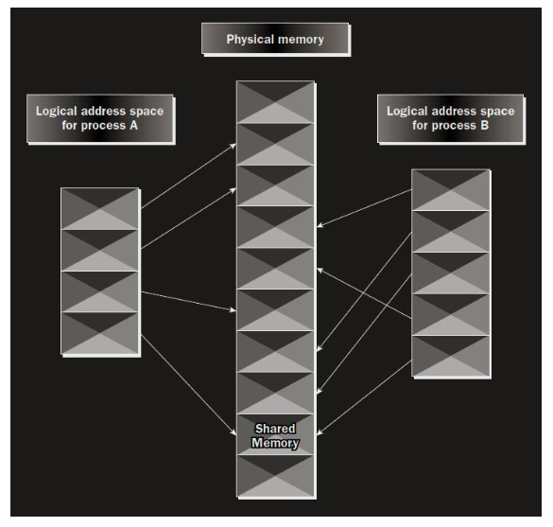

The arrows show the mapping of the logical address space of each process to the physical

memory available. In practice, the situation is more complex because the available memory

actually consists of a mix of physical memory and memory pages that have been swapped

out to disk. The functions for shared memory resemble those for semaphores:

#include <sys/shm.h>

void \*shmat(int shm\_id, const void \*shm\_addr, int shmflg);

int shmctl(int shm\_id, int cmd, struct shmid\_ds \*buf);

int shmdt(const void \*shm\_addr);

int shmget(key\_t key, size\_t size, int shmflg);

As with semaphores, the include files sys/types.h and sys/ipc.h are normally automatically

included by shm.h.

shmget()It is used to create shared memory

int shmget(key\_t key, size\_t size, int shmflg);

As with semaphores, the program provides key, which effectively names the shared

memory segment, and the shmget function returns a shared memory identifier that is used

in subsequent shared memory functions. There’s a special key value, IPC\_PRIVATE, that

creates shared memory private to the process.The second parameter, size, specifies the

amount of memory required in bytes.The third parameter, shmflg, consists of nine

permission flags that are used in the same way as the mode flags for creating files. A

special bit defined by IPC\_CREAT must be bitwise ORed with the permissions to create a

new shared memory segment. It’s not an error to have the IPC\_CREAT flag set and pass

the key of an existing shared memory segment. The IPC\_CREAT flag is silently ignored if

it is not required.If the shared memory is successfully created, shmget returns a

nonnegative integer, the shared memory identifier. On failure, it returns –1.

shmat()

When we first create a shared memory segment, it’s not accessible by any process.

Toenable access to the shared memory, we must attach it to the address space of a process.

We do this with the shmat function:

void \*shmat(int shm\_id, const void \*shm\_addr, int shmflg);

The first parameter, shm\_id, is the shared memory identifier returned from shmget. The

second parameter, shm\_addr, is the address at which the shared memory is to be attached to

the current process. This should almost always be a null pointer, which allows the system

to choose the address at which the memory appears.The third parameter, shmflg, is a set of

bitwise flags. The two possible values are SHM\_R for writing and SHM\_W for write

access. If the shmat call is successful, it returns a pointer to the first byte of shared memory.

On failure –1 is returned.

shmctl( )

it is used for controlling functions for shared memory.

int shmctl(int shm\_id, int command, struct shmid\_ds \*buf);

The shmid\_ds structure has at least the following members:

struct shmid\_ds{uid\_t shm\_perm.uid;uid\_t shm\_perm.gid;

mode\_t shm\_perm.mode;}

The first parameter, shm\_id, is the identifier returned from shmget. The second

parameter,command, is the action to take. It can take three values, shown in the following

table.

Command Description

IPC\_STAT : Sets the data in the shmid\_ds structure to reflect the values associated

with the shared memory.

IPC\_SET: Sets the values associated with the shared memory to those provided in the

shmid\_ds data structure, if the process has permission to do so.

IPC\_RMID: Deletes the shared memory segment.

The third parameter, buf, is a pointer to the structure containing the modes and permissions

for the shared memory.

References :

1. “Beginning Linux Programming” by Neil Mathew and Richard Stones, Wrox

Publications.

2. “Operating System Internals and Design Implementation” by William Stallings, Pearson

Education.

**ASSIGNMENT No: 10**

**Title :** Disk scheduling algorithms

**AIM :** To implement C programs for Disk scheduling algorithms

1. SSTF

2. SCAN

3. C-LOOK

**Theory :**

INTRODUCTION

In operating systems, seek time is very important. Since all device requests are linked in

queues, the seek time is increased causing the system to slow down. Disk Scheduling

Algorithms are used to reduce the total seek time of any request.

PURPOSE

The purpose of this material is to provide one with help on disk scheduling algorithms.

Hopefully with this, one will be able to get a stronger grasp of what disk scheduling

algorithms do.

TYPES OF DISK SCHEDULING ALGORITHMS

Although there are other algorithms that reduce the seek time of all requests, I will only

concentrate on the following disk scheduling algorithms:

First Come-First Serve (FCFS)

Shortest Seek Time First (SSTF)

Elevator (SCAN)

Circular SCAN (C-SCAN)

LOOK

C-LOOK

These algorithms are not hard to understand, but they can confuse someone because they

are so similar. What we are striving for by using these algorithms is keeping Head

Movements (# tracks) to the least amount as possible. The less the head has to move the

faster the seek time will be. I will show you and explain to you why C-LOOK is the best

algorithm to use in trying to establish less seek time.

Given the following queue -- 95, 180, 34, 119, 11, 123, 62, 64 with the Read-write head

initially at the track 50 and the tail track being at 199 let us now discuss the different

algorithms.

1. First Come -First Serve (FCFS)

All incoming requests are placed at the end of the queue. Whatever number that is next in

the queue will be the next number served. Using this algorithm doesn't provide the best

results. To determine the number of head movements you would simply find the number of

tracks it took to move from one request to the next. For this case it went from 50 to 95 to

180 and so on. From 50 to 95 it moved 45 tracks. If you tally up the total number of tracks

you will find how many tracks it had to go through before finishing the entire request. In

this example, it had a total head movement of 640 tracks. The disadvantage of this

algorithm is noted by the oscillation from track 50 to track 180 and then back to track 11 to

123 then to 64. As you will soon see, this is the worse algorithm that one can use.

Figure 1: First Come -First Serve (FCFS)

2. Shortest Seek Time First (SSTF)

In this case request is serviced according to next shortest distance. Starting at 50, the next

shortest distance would be 62 instead of 34 since it is only 12 tracks away from 62 and 16

tracks away from 34. The process would continue until all the process are taken care of.

For example the next case would be to move from 62 to 64 instead of 34 since there are

only 2 tracks between them and not 18 if it were to go the other way. Although this seems

to be a better service being that it moved a total of 236 tracks, this is not an optimal one.

There is a great chance that starvation would take place. The reason for this is if there were

a lot of requests close to eachother the other requests will never be handled since the

distance will always be greater.

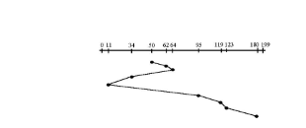

Figure 2: Shortest Seek Time First (SSTF)

3. Elevator (SCAN)

This approach works like an elevator does. It scans down towards the nearest end and then

when it hits the bottom it scans up servicing the requests that it didn't get going down. If a

request comes in after it has been scanned it will not be serviced until the process comes

back down or moves back up. This process moved a total of 230 tracks. Once again this is

more optimal than the previous algorithm, but it is not the best.

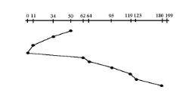

4. Circular Scan (C-SCAN)

Circular scanning works just like the elevator to some extent. It begins its scan toward the

nearest end and works it way all the way to the end of the system. Once it hits the bottom

or top it jumps to the other end and moves in the same direction. Keep in mind that the

huge jump doesn't count as a head movement. The total head movement for this algorithm

is only 187 track, but still this isn't the mose sufficient

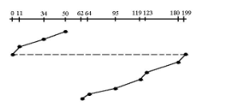

Figure 4: Circular Scan (C-SCAN)

5. C-LOOK

This is just an enhanced version of C-SCAN. In this the scanning doesn't go past the last

request in the direction that it is moving. It too jumps to the other end but not all the way to

the end. Just to the furthest request. C-SCAN had a total movement of 187 but this scan (C-

LOOK) reduced it down to 157 tracks.

From this you were able to see a scan change from 644 total head movements to just 157.

You should now have an understanding as to why your operating system truly relies on the

type of algorithm it needs when it is dealing with multiple processes.

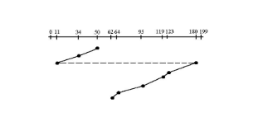

Figure 5: C-LOOK

Assignment:

Given the following queue -- 195, 80, 134, 19, 111, 132, 162, 164 with the Read-write head

initially at the track 150 and the tail track being at 199, implement disk scheduling to

calculate head movements for SSTF, SCAN, C-LOOK

**ASSIGNMENT No: 11**

**Title :** System Call

**AIM :** Implement a new system call, add this new system call in the Linux kernel (any

kernel source, any architecture and any Linux kernel distribution) and demonstrate the use

of same.

**OBJECTIVE:** add a new system call, swipe(), to the Linux kernel that transfers the

remaining time slice of each process in a specified set to a target process. You will also

demonstrate various uses of the system call (both advantageous and detrimental)

**THEORY:**

Adding a simple system call

1. Download the kernel source:

In your terminal type the following command:

wget https://www.kernel.org/pub/linux/kernel/v4.x/linux-4.17.4.tar.xz

Else go to kernel.org and download the latest version.

2. Extract the kernel source code

sudo tar -xvf linux-4.17.4.tar.xz -C/usr/src/

tar — Tar stores and extracts files from a tape or disk archive.

-x — extract files from an archive

-v — requested using the –verbose option, when extracting archives

-f — file archive; use archive file or device archive

-C — extract to the directory specified after it.(in this case /usr/src/)

Now, we’ll change the directory to where the files are extracted:

cd /usr/src/linux-4.17.4

3. Define a new system call sys\_hello( )

Create a directory named hello/ and change the directory to hello/:

mkdir hello

cd hello

Create a file hello.c using text editor:

gedit hello.c

Write the following code in the editor:

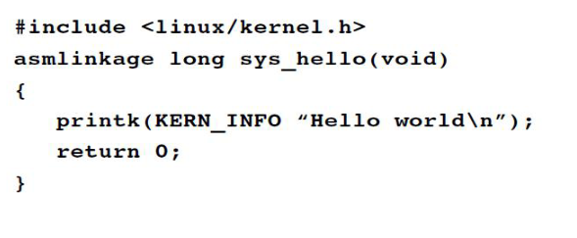

printk prints to the kernel’s log file.

Create a “Makefile” in the hello directory:

gedit Makefile

and add the following line to it:

obj-y := hello.o

This is to ensure that the hello.c file is compiled and included in the kernel source code.

Note: There is no space in between“obj-y”.

4. Adding hello/ to the kernel’s Makefile:

Go back to the parent dir i.e. cd ../ and open “Makefile”

gedit Makefile

search for core-y in the document, you’ll find this line as the second instance of your search:

core-y += kernel/ mm/ fs/ ipc/ security/ crypto/ block/

Add ‘hello/’ to the end of this line:

core-y += kernel/ mm/ fs/ ipc/ security/ crypto/ block/ hello/

Note: There is a space between “block/” and “hello/”. (Doing such a mistake may cause

errors in further steps)

This is to tell the compiler that the source files of our new system call (sys\_hello()) are in

present in the hello directory.

5. Add the new system call to the system call table:

If you are on a 32-bit system you’ll need to change ‘syscall\_32.tbl’. For 64-bit, change

‘syscall\_64.tbl’.

Run the following commands in your terminal from linux-4.17.4/ directory:

cd arch/x86/entry/syscalls/

gedit syscall\_64.tbl

You’ll get a file like the following in your editor

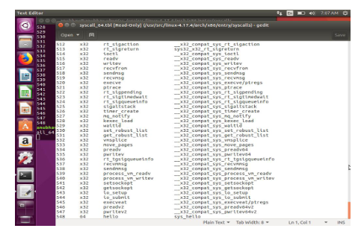

Go to the last of the document and add a new line like so:

548 64 hello sys\_hello

Note:

Here 548 is written because in the previous line the number entry was 547.

Remember this number it will be used in the later steps.

Also, note that I’ve written 64 in my system because it is 64 bit. You may have to

write i586 or x32. For knowing what is to be written check in this file itself in many

of the lines you may find entries like so

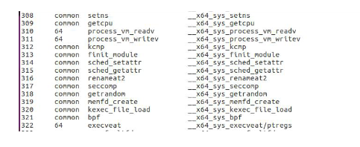

Information Technology Dept. Operating System Lab Manual

P:F:-LTL-UG / 03 / R1 Sheet 71 of 74

Go to the last of the document and add a new line like so:

548 64 hello sys\_hello

Note:

Here 548 is written because in the previous line the number entry was 547.

Remember this number it will be used in the later steps.

Also, note that I’ve written 64 in my system because it is 64 bit. You may have to

write i586 or x32. For knowing what is to be written check in this file itself in many

of the lines you may find entries like so:

64 written at 310, 311 and 322 line numbers

This will tell you whether to write i586 or something else.

Save and exit.

6. Add new system call to the system call header file:

Go to the linux-4.17.4/ directory and type the following commands:

cd include/linux/

gedit syscalls.h

Add the following line to the end of the document before the #endif statement:

asmlinkage long sys\_hello(void);

Save and exit. This defines the prototype of the function of our system call. “asmlinkage” is

a key word used to indicate that all parameters of the function would be available on the

stack

7. Compile the kernel:

Before starting to compile you need to install a few packages. Type the following

commands in your terminal:

sudo apt-get install gcc

sudo apt-get install libncurses5-dev

sudo apt-get install bison

sudo apt-get install flex

sudo apt-get install libssl-dev

sudo apt-get install libelf-dev

sudo apt-get update

sudo apt-get upgrade

to configure your kernel use the following command in your linux-4.17.4/ directory:

sudo make menuconfig

Once the above command is used to configure the Linux kernel, you will get a pop up

window with the list of menus and you can select the items for the new configuration. If

your unfamiliar with the configuration just check for the file systems menu and check

whether “ext4” is chosen or not, if not select it and save the configuration.

Now to compile the kernel you can use the make command:

sudo make

Pro Tip: The make command can take a lot of time in compiling, to speed up the process

you can take advantage of the multiple cores that our systems have these days. Simply type,

sudo make -jn

where n is the number of cores that you have in your linux system. For example if you have

a Quad core(4) processor, you can write:

sudo make -j4

this will speed up my make process 4x times. ;)

This might take an hours or more depending on your system.

8. Install / update Kernel:

Run the following command in your terminal:

sudo make modules\_install install

It will create some files under /boot/ directory and it will automatically make a entry in your

grub.cfg. To check whether it made correct entry, check the files under /boot/ directory . If

you have followed the steps without any error you will find the following files in it in

addition to others.

1. System.map-4.17.4

2. vmlinuz-4.17.4

3. initrd.img-4.17.4

4. config-4.17.4

Now to update the kernel in your system reboot the system . You can use the following

command:

shutdown -r now

After rebooting you can verify the kernel version using the following command:

uname -r

It will display the kernel version like so:

4.17.4

9. Test system call:

Go to your home(~) directory using the following commands and create a userspace.c file.

cd ~

gedit userspace.c

Write the following code in this file:

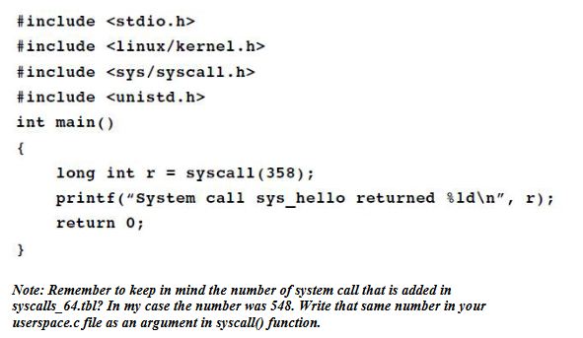

Now, compile and run the program:

gcc userspace.c

./a.out

If all the steps are done correctly, you’ll get an output like below:

System call sys\_hello returned 0

Now, to check the message of your kernel run the following command:

dmesg

This will display Hello world at the end of the kernel’s message.